**Tweet Data**

* Data Scraping
  + [Twint](https://github.com/twintproject/twint): A Python scraping library for collecting the Twitter users’ data.
  + [NLTK](https://www.nltk.org/): A language analysis library to convert tweets into formalized keywords.
* Sentiment Analysis
  + [vaderSentiment](https://pypi.org/project/vaderSentiment/): A language analysis library to analyze the sentiment intensity.

**BTC Price Prediction**

* Data Normalization
  + For some numerical variables, because their value ranges vary greatly, it is often necessary to organize their value ranges into a reasonable range.
  + MinMaxScaler： 
    - Min-Max only change the the value range. It does not change the distribution.

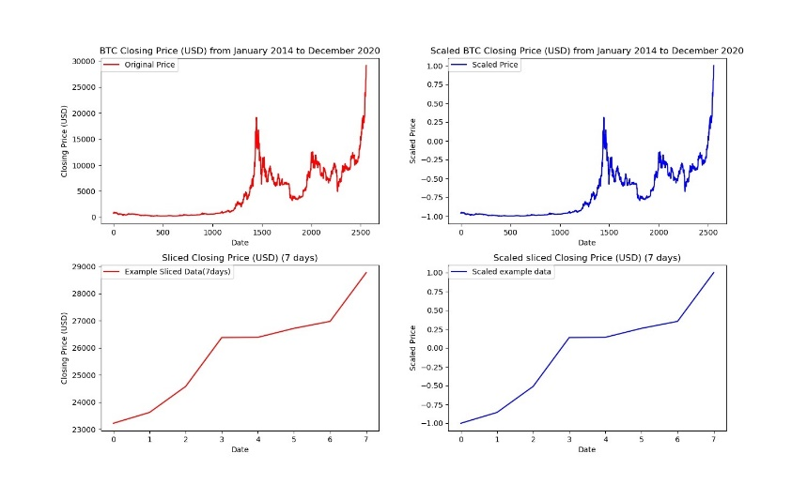

* Model
  + Long short-term memory (LSTM)

<https://towardsdatascience.com/illustrated-guide-to-lstms-and-gru-s-a-step-by-step-explanation-44e9eb85bf21>

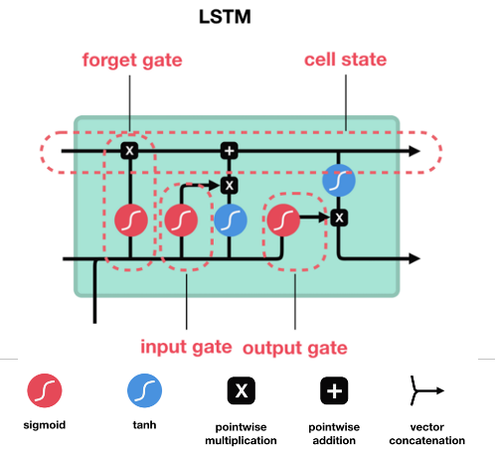

* + Gated Recurrent Units (GRU)

<https://towardsdatascience.com/illustrated-guide-to-lstms-and-gru-s-a-step-by-step-explanation-44e9eb85bf21>

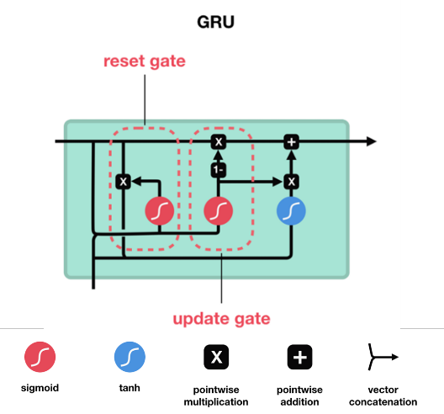

* + Bidirectional Long short-term memory (Bi-LSTM)

Reimers, N., & Gurevych, I. (2017). Optimal hyperparameters for deep lstm-networks for sequence labeling tasks. arXiv preprint arXiv:1707.06799.

